**Capstone Design Projects 2019-20**

**Progress Report**

**Music Transcription**

**Group Member & NetID:**

Sifan Yuan sy609

Haocong Wang mw814

**1 Progress & Challenge**

After last meeting, we work on the data analyzing part of the plan. To change the data into a time-frequency domain, we use the algorithm of spectrogram and chroma gram to process the audio we get before.

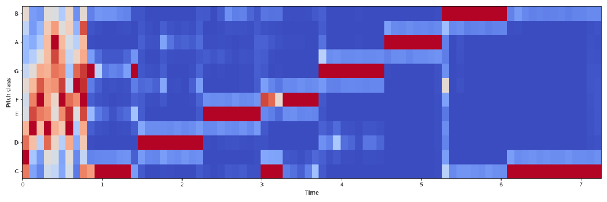

By using these two kinds of data, we successfully divide the audio by every single note and also can label the note by different pitch. In a word, we can now transcript some simple music (the plot picture shows the audio of a single music scale).

But as the spectrogram shows, the frequency of a single pitch will reflect on different frequency bands. So, it is difficult to determine which octave (from a lower *do* to a higher *do*) does the pitch in. This also can’t be solved by the chroma gram too. Chroma gram can get the exactly pitch of different frequency, but it can’t figure out which octave does this pitch in.

Then, how to organize the data more clearly and concisely is a problem too.

What’s more, how to deal with the noise is also a big challenge of the music transcription, and this is also what we are doing now.

**2 Possible Solution**

To solve the problem of the exact octave determination, we want to compare the strength of the pitch in different frequency bands to get the highest one to be the target.

To organize the data, we can define another variable to let the user control the tempo. For we can get the exact time length of a single time stamp by the sampling rate and the hop length

To solve the noise problem, we may use some filter to preprocess the data, so that we can improve the accuracy of our project.

**3 Future Plan**

|  |  |  |
| --- | --- | --- |
| **Task Name** | **Progress (%)** | **Estimated Completion Date** |
| Extract the audio data | 100% |  |
| Analyze the data in the frequency domain | 90% | 2020.03.22 |
| Label the data by pitch | 80% | 2020.03.22 |
| Divide the data into a single note | 100% |  |
| Create the MIDI file | 20% | 2020.03.31 |
| Deal with the noise | 30% | 2020.04.05 |
| Apply the UI | 10% | 2020.04.16 |